Section A

- Complete the word equation for fermentation.

Glucose _________________ + _________________

- Which explains why fermentation is an anaerobic process?
Tick ( ) one box.
- It takes place in the presence of oxygen | 
- It takes place in the absence of oxygen
- It involves anaerobic respiration

- Choose the most suitable temperature for fermentation to take place.
Tick ( ) one box.
- 10 ºC
- 30 ºC
- 40 ºC

- Complete the structural formula for ethanol:

C C

- Give a use for ethanol other than in alcoholic drinks.

__________________________________________________________________________________________

- Give a use for the other product of fermentation.

__________________________________________________________________________________________

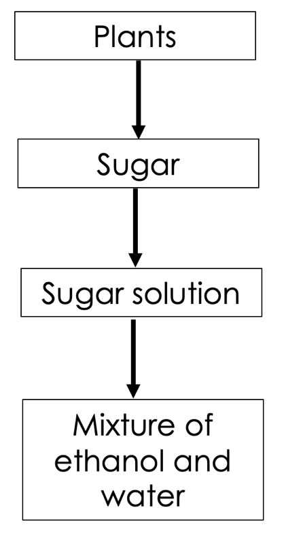
Section B

- The flowchart shows some of the substances involved in the production of ethanol.

- Name the process that can be used to make ethanol from plant sugars.

_________________________________________________

- Describe how the sugar solution is used to produce the mixture of ethanol and water.

____________________________________________________________
____________________________________________________________
____________________________________________________________
____________________________________________________________
____________________________________________________________
________________________________________________________________________________________________________________________________________________________________________________________________________________________________________________________________________________________________________________________________________________________________

- Describe the advantages and disadvantages of this method of producing ethanol.

__________________________________________________________________________________________
__________________________________________________________________________________________
__________________________________________________________________________________________
__________________________________________________________________________________________

- Describe how ethanol could be separated from the mixture of ethanol and water. Ethanol has a boiling point of 78 ºC and water has a boiling point of 100 ºC.

__________________________________________________________________________________________
__________________________________________________________________________________________
__________________________________________________________________________________________
__________________________________________________________________________________________

- Ethanol made by this method can be used as a biofuel. Suggest the impact this may have on food security.

__________________________________________________________________________________________
__________________________________________________________________________________________
__________________________________________________________________________________________
__________________________________________________________________________________________

- Explain why burning biofuels contributes less to global warming than burning fossil fuels.

__________________________________________________________________________________________
__________________________________________________________________________________________
__________________________________________________________________________________________
__________________________________________________________________________________________

- The apparatus below shows how ethanol can be made from sugar solution and yeast.

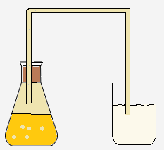

Limewater

Sugar solution + yeast

  - Describe and explain the change that would be seen in the limewater.

__________________________________________________________________________________________
__________________________________________________________________________________________
__________________________________________________________________________________________

  - Once the reaction has taken place, the solid yeast can be separated from the solution.
Describe how the solid yeast could be separated from the solution.

__________________________________________________________________________________________
__________________________________________________________________________________________
__________________________________________________________________________________________

Section C

- Ethanol can be produced by fermentation.
- Name the microorganism that is added to a sugar solution to produce ethanol.
- Enzymes in the microorganism increase the rate of reaction. Define an enzyme.
- Explain what is meant by the lock-and-key model of enzyme activity.
- Define the optimum temperature of an enzyme.
- Describe what happens to an enzyme when it is heated too much.

